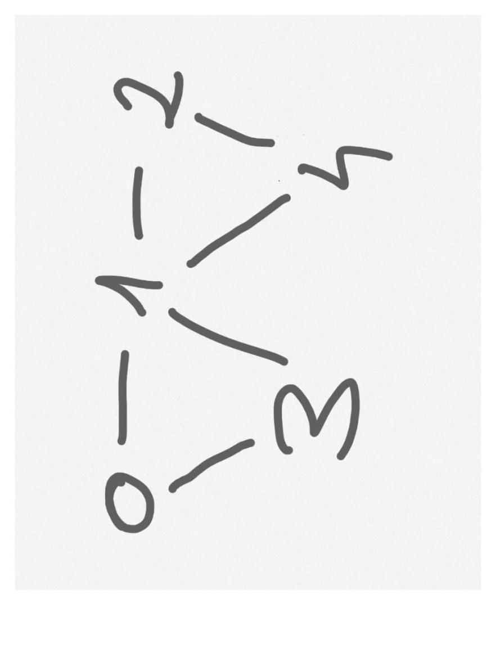

5 6

0 1

0 3

1 2

1 3

1 4

2 4

Vertex cover result: [0, 1, 2]

Iteration 1)

K = 1

In combinations:

List = [0], 1 element - check vertex cover returns false, we continue

List = [1], 1 element - check vertex cover returns false, we continue

List = [2], 1 element - check vertex cover returns false, we continue

List = [3], 1 element - check vertex cover returns false, we continue

List = [4], 1 element - check vertex cover returns false, we continue

Iteration 2)

K = 2

In combinations:

List = [0, 1], 2 elements - check vertex cover returns false, we continue

List = [0, 2], 2 elements - check vertex cover returns false, we continue

List = [0, 3], 2 elements - check vertex cover returns false, we continue

List = [0, 4], 2 elements - check vertex cover returns false, we continue

List = [1, 0], 2 elements - check vertex cover returns false, we continue

List = [1, 2], 2 elements - check vertex cover returns false, we continue

List = [1, 3], 2 elements - check vertex cover returns false, we continue

List = [1, 4], 2 elements - check vertex cover returns false, we continue

List = [2, 0], 2 elements - check vertex cover returns false, we continue

List = [2, 1], 2 elements - check vertex cover returns false, we continue

List = [2, 3], 2 elements - check vertex cover returns false, we continue

List = [2, 4], 2 elements - check vertex cover returns false, we continue

List = [3, 0], 2 elements - check vertex cover returns false, we continue

List = [3, 1], 2 elements - check vertex cover returns false, we continue

List = [3, 2], 2 elements - check vertex cover returns false, we continue

List = [3, 4], 2 elements - check vertex cover returns false, we continue

List = [4, 0], 2 elements - check vertex cover returns false, we continue

List = [4, 1], 2 elements - check vertex cover returns false, we continue

List = [4, 2], 2 elements - check vertex cover returns false, we continue

List = [4, 3], 2 elements - check vertex cover returns false, we continue

Iteration 2)

K = 2

In combinations:

List = [0, 1, 2], 3 elements - check vertex cover returns true, we stop